4.24: (a) Each crate can be considered a single particle:
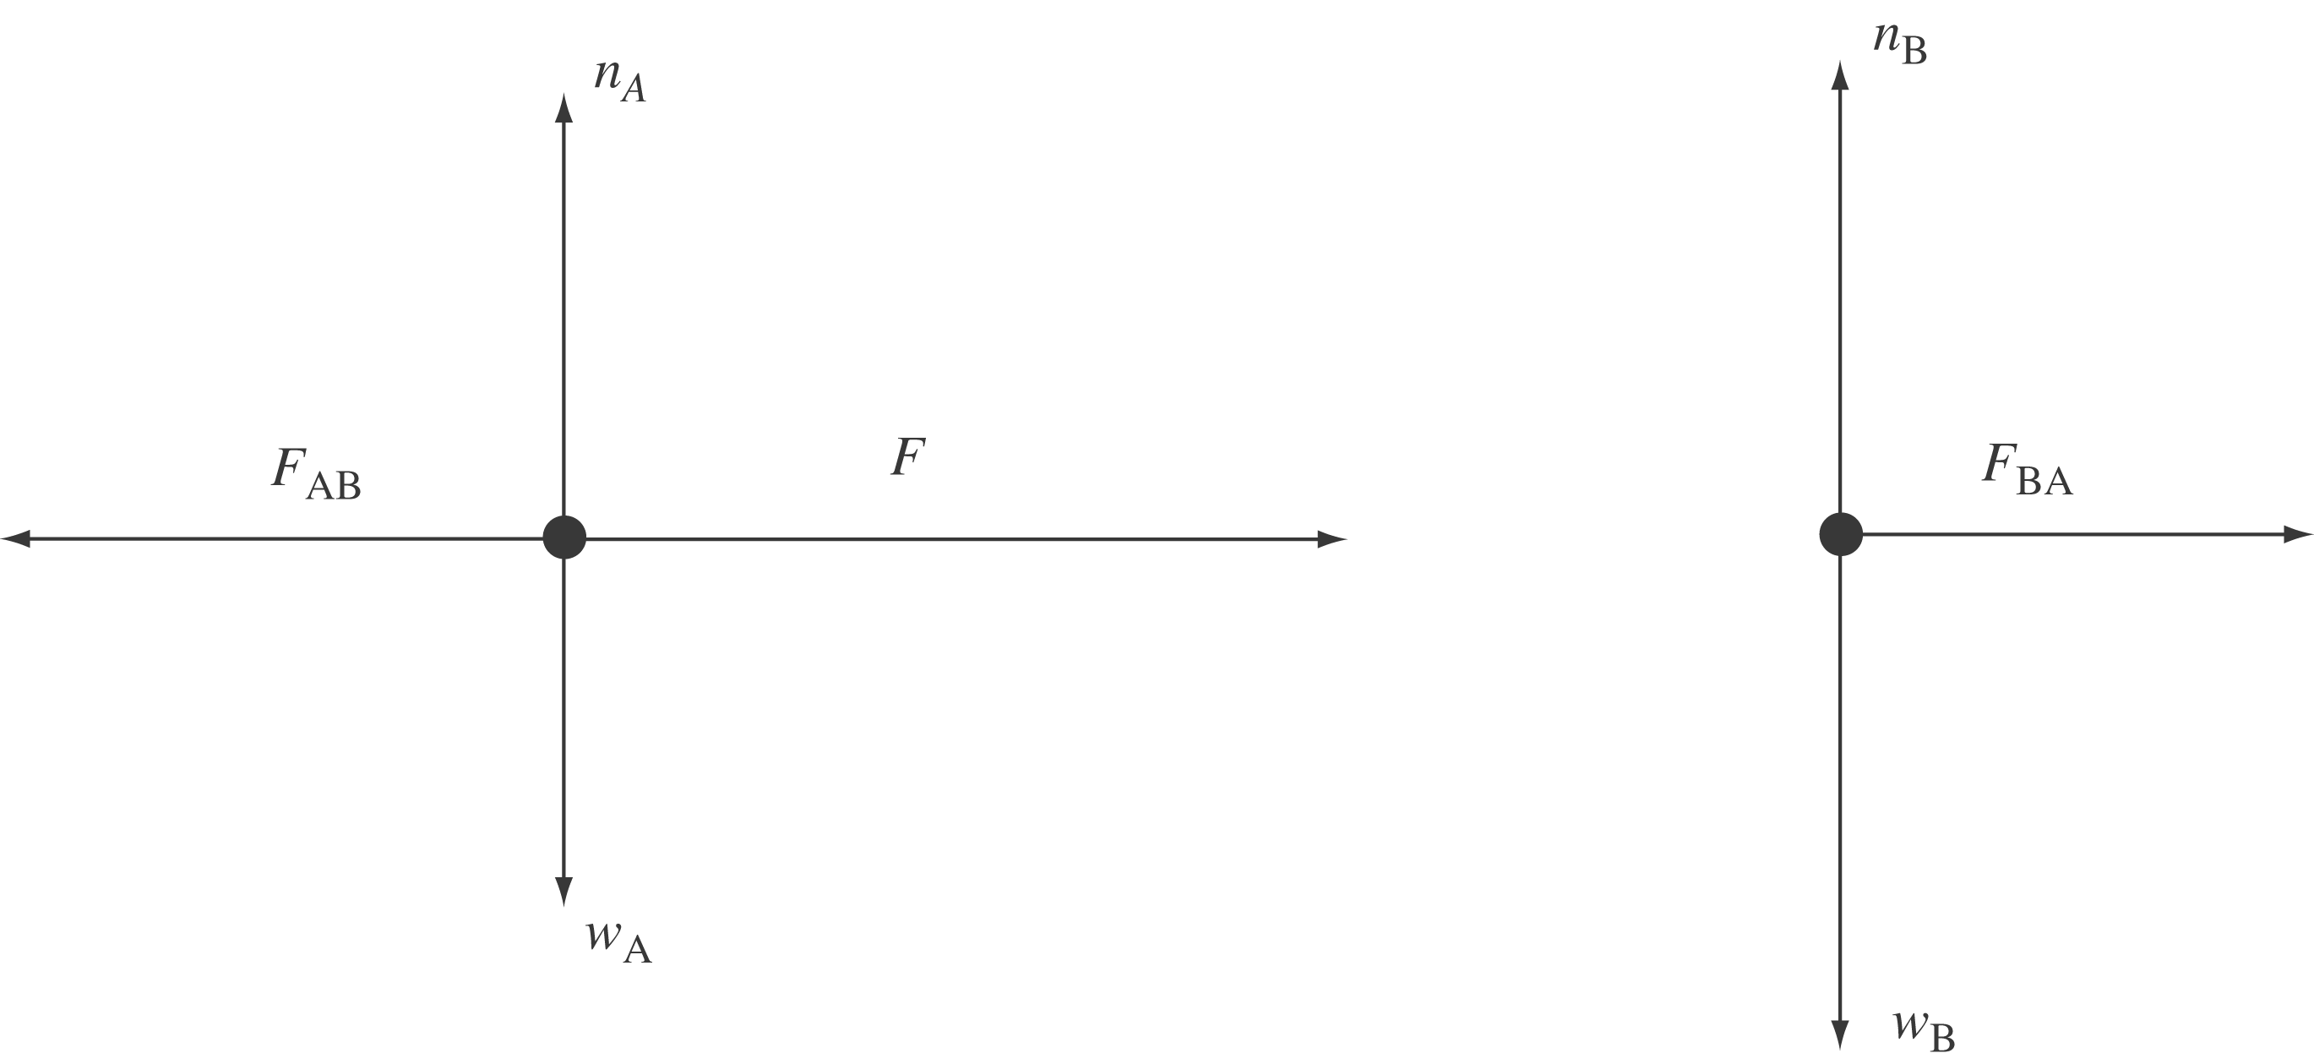
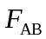 (the force on 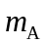 due to 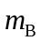) and 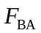 (the force on due to ) form an action-reaction pair.
(b) Since there is no horizontal force opposing F, any value of F, no matter how small, will cause the crates to accelerate to the right. The weight of the two crates acts at a right angle to the horizontal, and is in any case balanced by the upward force of the surface on them.

